Worksheet 2.1
Student Name: Ayush Yadav UID: 25IMC13004
Branch: MCA (AI & ML) Section/Group: MAM-1 (A)
Semester: II Date of Performance: 02/02/26
Subject Name: Advance Internet Programming Subject Code: 25CAP-656

1. Aim/Overview of the practical: To design and develop a Java EE application that demonstrates inter-servlet communication by using RequestDispatcher to forward requests and sendRedirect() to redirect responses between servlets.

2. Coding:
Index.html file:
<!DOCTYPE html>
<html lang="en">
<head>
<link href="https://cdn.jsdelivr.net/npm/bootstrap@5.3.2/dist/css/bootstrap.min.css" rel="stylesheet">
</head>
<body class="bg-light d-flex justify-content-center align-items-center vh-100">

<form class="p-4 shadow rounded bg-white w-45 mx-3" action="Servlet1" method="post">
<h3 class="text-center mb-4">Registration Form using post method</h3>

<div class="mb-3">
<label for="name" class="form-label">Name</label>
<input type="text" class="form-control" name="name" id="name" placeholder="Enter your name">
</div>

<div class="mb-3">
<label for="age" class="form-label">Age</label>
<input type="number" class="form-control" name="age" id="age" placeholder="Enter your age">
</div>

<button type="submit" class="btn btn-primary w-100">Submit</button>
</form>

<script src="https://cdn.jsdelivr.net/npm/bootstrap@5.3.2/dist/js/bootstrap.bundle.min.js"></script>
</body>
</html>
Servlet1 file:
import java.io.IOException;
import java.io.PrintWriter;
import jakarta.servlet.ServletException;
import jakarta.servlet.RequestDispatcher;
import jakarta.servlet.annotation.WebServlet;
import jakarta.servlet.http.HttpServlet;
import jakarta.servlet.http.HttpServletRequest;
import jakarta.servlet.http.HttpServletResponse;

@WebServlet(urlPatterns = {"/Servlet1"})
public class Servlet1 extends HttpServlet {
protected void processRequest(HttpServletRequest request, HttpServletResponse response)
throws ServletException, IOException {
response.setContentType("text/html;charset=UTF-8");

String name = request.getParameter("name");
String age = request.getParameter("age");

request.setAttribute("userName", name);
request.setAttribute("userAge", age);

RequestDispatcher rd = request.getRequestDispatcher("Servlet2");
rd.forward(request, response);
// response.sendRedirect("https://github.com/");
}
@Override
protected void doGet(HttpServletRequest request, HttpServletResponse response)
throws ServletException, IOException {
processRequest(request, response);
}

@Override
protected void doPost(HttpServletRequest request, HttpServletResponse response)
throws ServletException, IOException {
processRequest(request, response);
}
}

Servlet2 file:
import java.io.IOException;
import java.io.PrintWriter;
import jakarta.servlet.ServletException;
import jakarta.servlet.annotation.WebServlet;
import jakarta.servlet.http.HttpServlet;
import jakarta.servlet.http.HttpServletRequest;
import jakarta.servlet.http.HttpServletResponse;

@WebServlet(urlPatterns = {"/Servlet2"})
public class Servlet2 extends HttpServlet {

protected void doPost(HttpServletRequest request, HttpServletResponse response)
throws ServletException, IOException {
response.setContentType("text/html;charset=UTF-8");

String name = (String) request.getAttribute("userName");
String age = (String) request.getAttribute("userAge");

try (PrintWriter out = response.getWriter()) {
out.println("<!DOCTYPE html>");
out.println("<html>");
out.println("<body>");
out.println("Name: " + name + "<br>");
out.println("Age: " + age);
out.println("</body>");
out.println("</html>");
}
}
}

Servlet1 with sendRedirect() method:
RequestDispatcher rd = request.getRequestDispatcher("Servlet2");
response.sendRedirect("https://github.com/");

-------- rest all code same in servlet1 -------

OUTPUT:
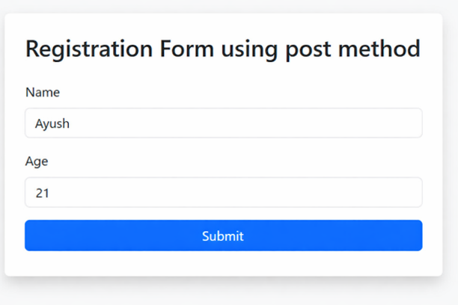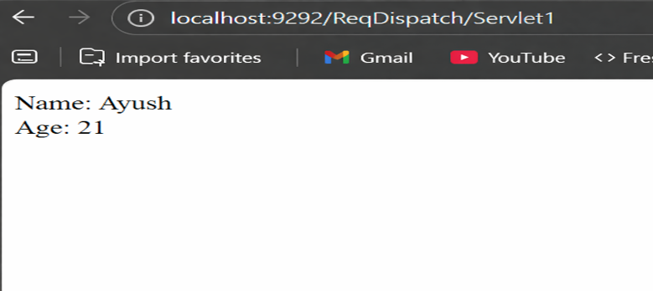
Figure 1: index.html file Figure 2: with forward() method

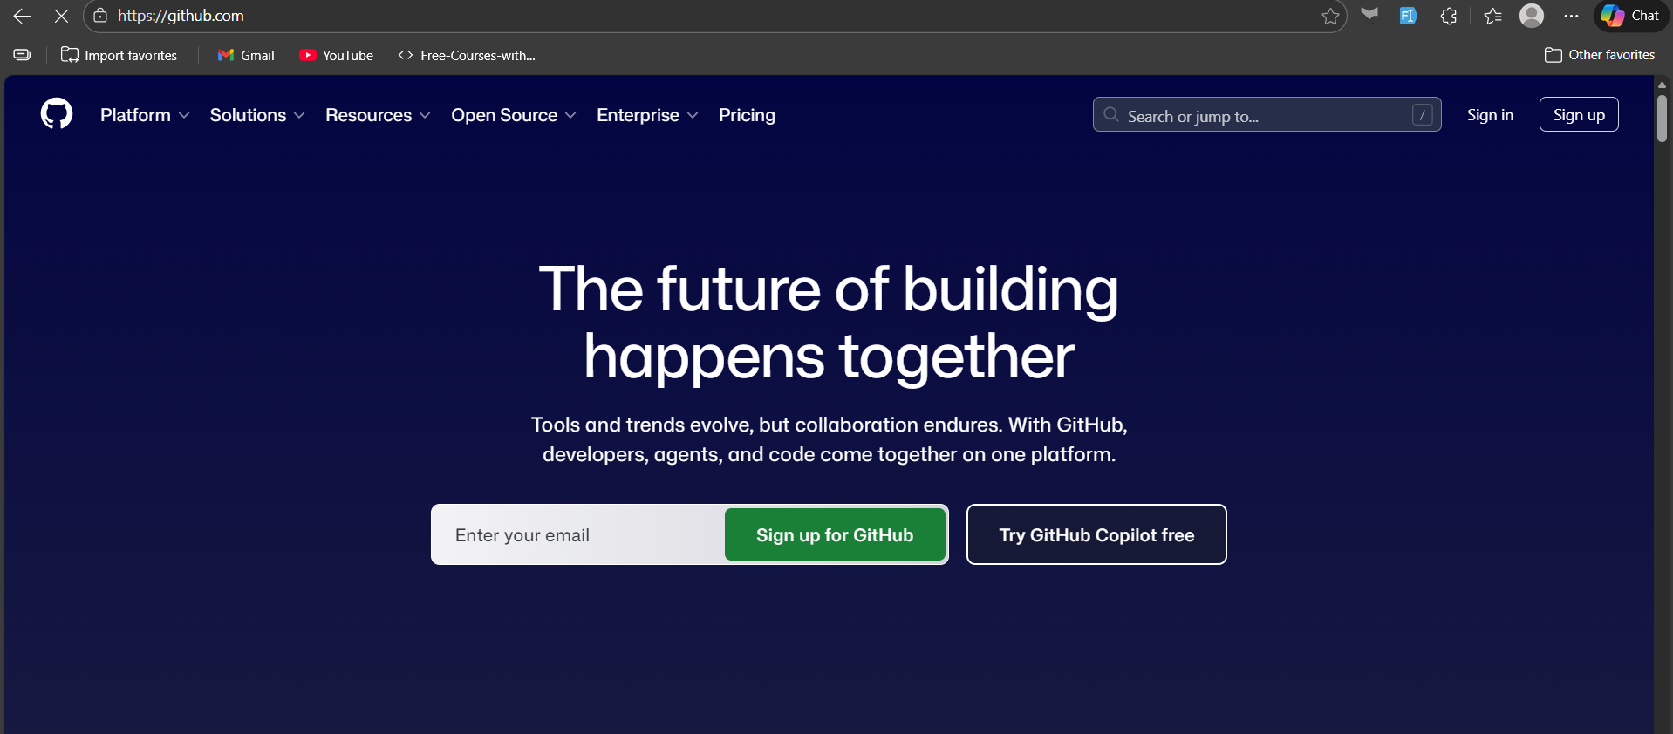
Figure 3: with sendRedirect() method
3. Learning outcomes:
- Understood how to transfer control between servlets using RequestDispatcher.
- Learned the difference between forward() and sendRedirect() in servlets.
- Implemented data sharing between servlets using request attributes.
- Observed how request scope data behaves during forwarding and redirection.
- Learned how form data flows from HTML to multiple servlets.

